Pg No.63









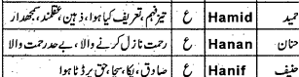



Pg.183







